2024 Summer Classics Season
At The Warsaw Federal Incline Theater

EXCITING Summer Packages ON Sale Now!

The hottest ticket in town just got hotter!! FOUR SHOWS at the sizzling price of only $112.00!
The Summer Classics Season will feature FOUR great musicals: BEAUTIFUL: THE CAROLE KING MUSICAL, JERSEY BOYS, PETER AND THE STARCATCHER and JIMMY BUFFET’S ESCAPE TO MARGARITAVILLE. Subscribe NOW to get the best deal and the best seats. Come join the party in summer 2024!

The 2024 Summer Classics Season includes:

BEAUTIFUL: THE CAROLE KING MUSICAL
April 17 – May 12, 2024
Words and Music by Gerry Goffin, Carole King, Barry Mann and Cynthia Weil Book by Douglas McGrath Music by Arrangement with Sony/ATV Music Publishing Orchestrations, Vocal and Incidental Music Arrangements
Steve Sidwell, Additional Music Arrangements by Jason Howland
Originally Produced on Broadway by Paul Blake, Sony/ATV Music Publishing and Mike Bosner
Beautiful is the inspiring tale about a girl who became King with a stirring book by the late Oscar and Tony-nominated Douglas McGrath and the music and lyrics of icons Carole King, Gerry Goffin, Barry Mann and Cynthia Weil. Featuring such unforgettable classics as "You've Got a Friend", "One Fine Day", "So Far Away", "Take Good Care of My Baby", "Up on the Roof", "You've Lost That Lovin' Feeling", "Will You Love Me Tomorrow", and "Natural Woman", this Tony® and Grammy® Award-winning musical phenomenon is filled with the songs you remember and a story you'll never forget.


JERSEY BOYS May 29 – June 23, 2024
Book by: Marshall Brickman and Rick Elice
Music by: Bob Gaudio, Lyrics by: Bob Crewe
With phenomenal music, memorable characters, and great storytelling, JERSEY BOYS follows the fascinating evolution of four blue-collar kids who became one of the greatest successes in pop-music history. Winner of Best Musical at both the Tony Awards® and Olivier Awards®, JERSEY BOYS takes you behind the music of Frankie Valli and The Four Seasons to discover the secret of a 40-year friendship as the foursome work their way from the streets of New Jersey to the heights of stardom. Thrill your audiences with electrifying performances of chart-topping hits including “Sherry,” “Big Girls Don’t Cry,” “Can’t Take My Eyes Off You,” “Dawn,” and “My Eyes Adored You,” which brought The Four Seasons the highest honor: induction into the Rock ‘n’ Roll Hall of Fame.

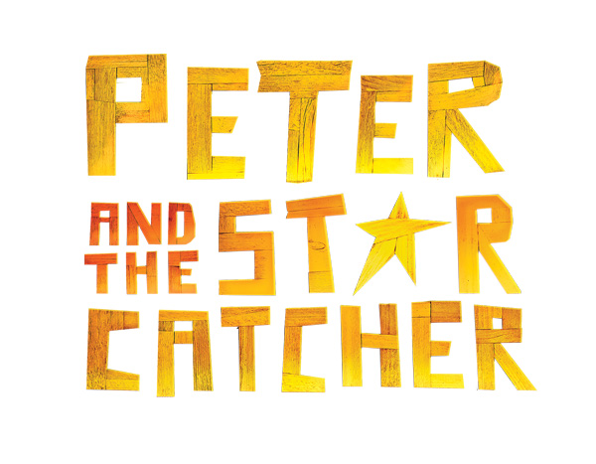
PETER AND THE STARCATCHER July 10 – August 4, 2024
A Play By RICK ELICE, Based on the Novel by Dave Barry and Ridley Pearson
Music By WAYNE BARKER
Tony-winning Peter and the Starcatcher upends the century-old story of how a miserable orphan comes to be The Boy Who Would Not Grow Up (a.k.a. Peter Pan). From marauding pirates and jungle tyrants to unwilling comrades and unlikely heroes, Peter and the Starcatcher playfully explores the depths of greed and despair... and the bonds of friendship, duty and love. A young orphan and his mates are shipped off from Victorian England to a distant island ruled by the evil King Zarboff. They know nothing of the mysterious trunk in the captain’s cabin, which contains a precious, otherworldly cargo. At sea, the boys are discovered by a precocious young girl named Molly, a Starcatcher-in-training who realizes that the trunk’s precious cargo is starstuff, a celestial substance so powerful that it must never fall into the wrong hands. When the ship is taken over by pirates – led by the fearsome Black Stache, a villain determined to claim the trunk and its treasure for his own – the journey quickly becomes a thrilling adventure.

SEE NEXT PAGE FOR THE FINAL BIG SHOW OF THE 2024 SUMMER SEASON

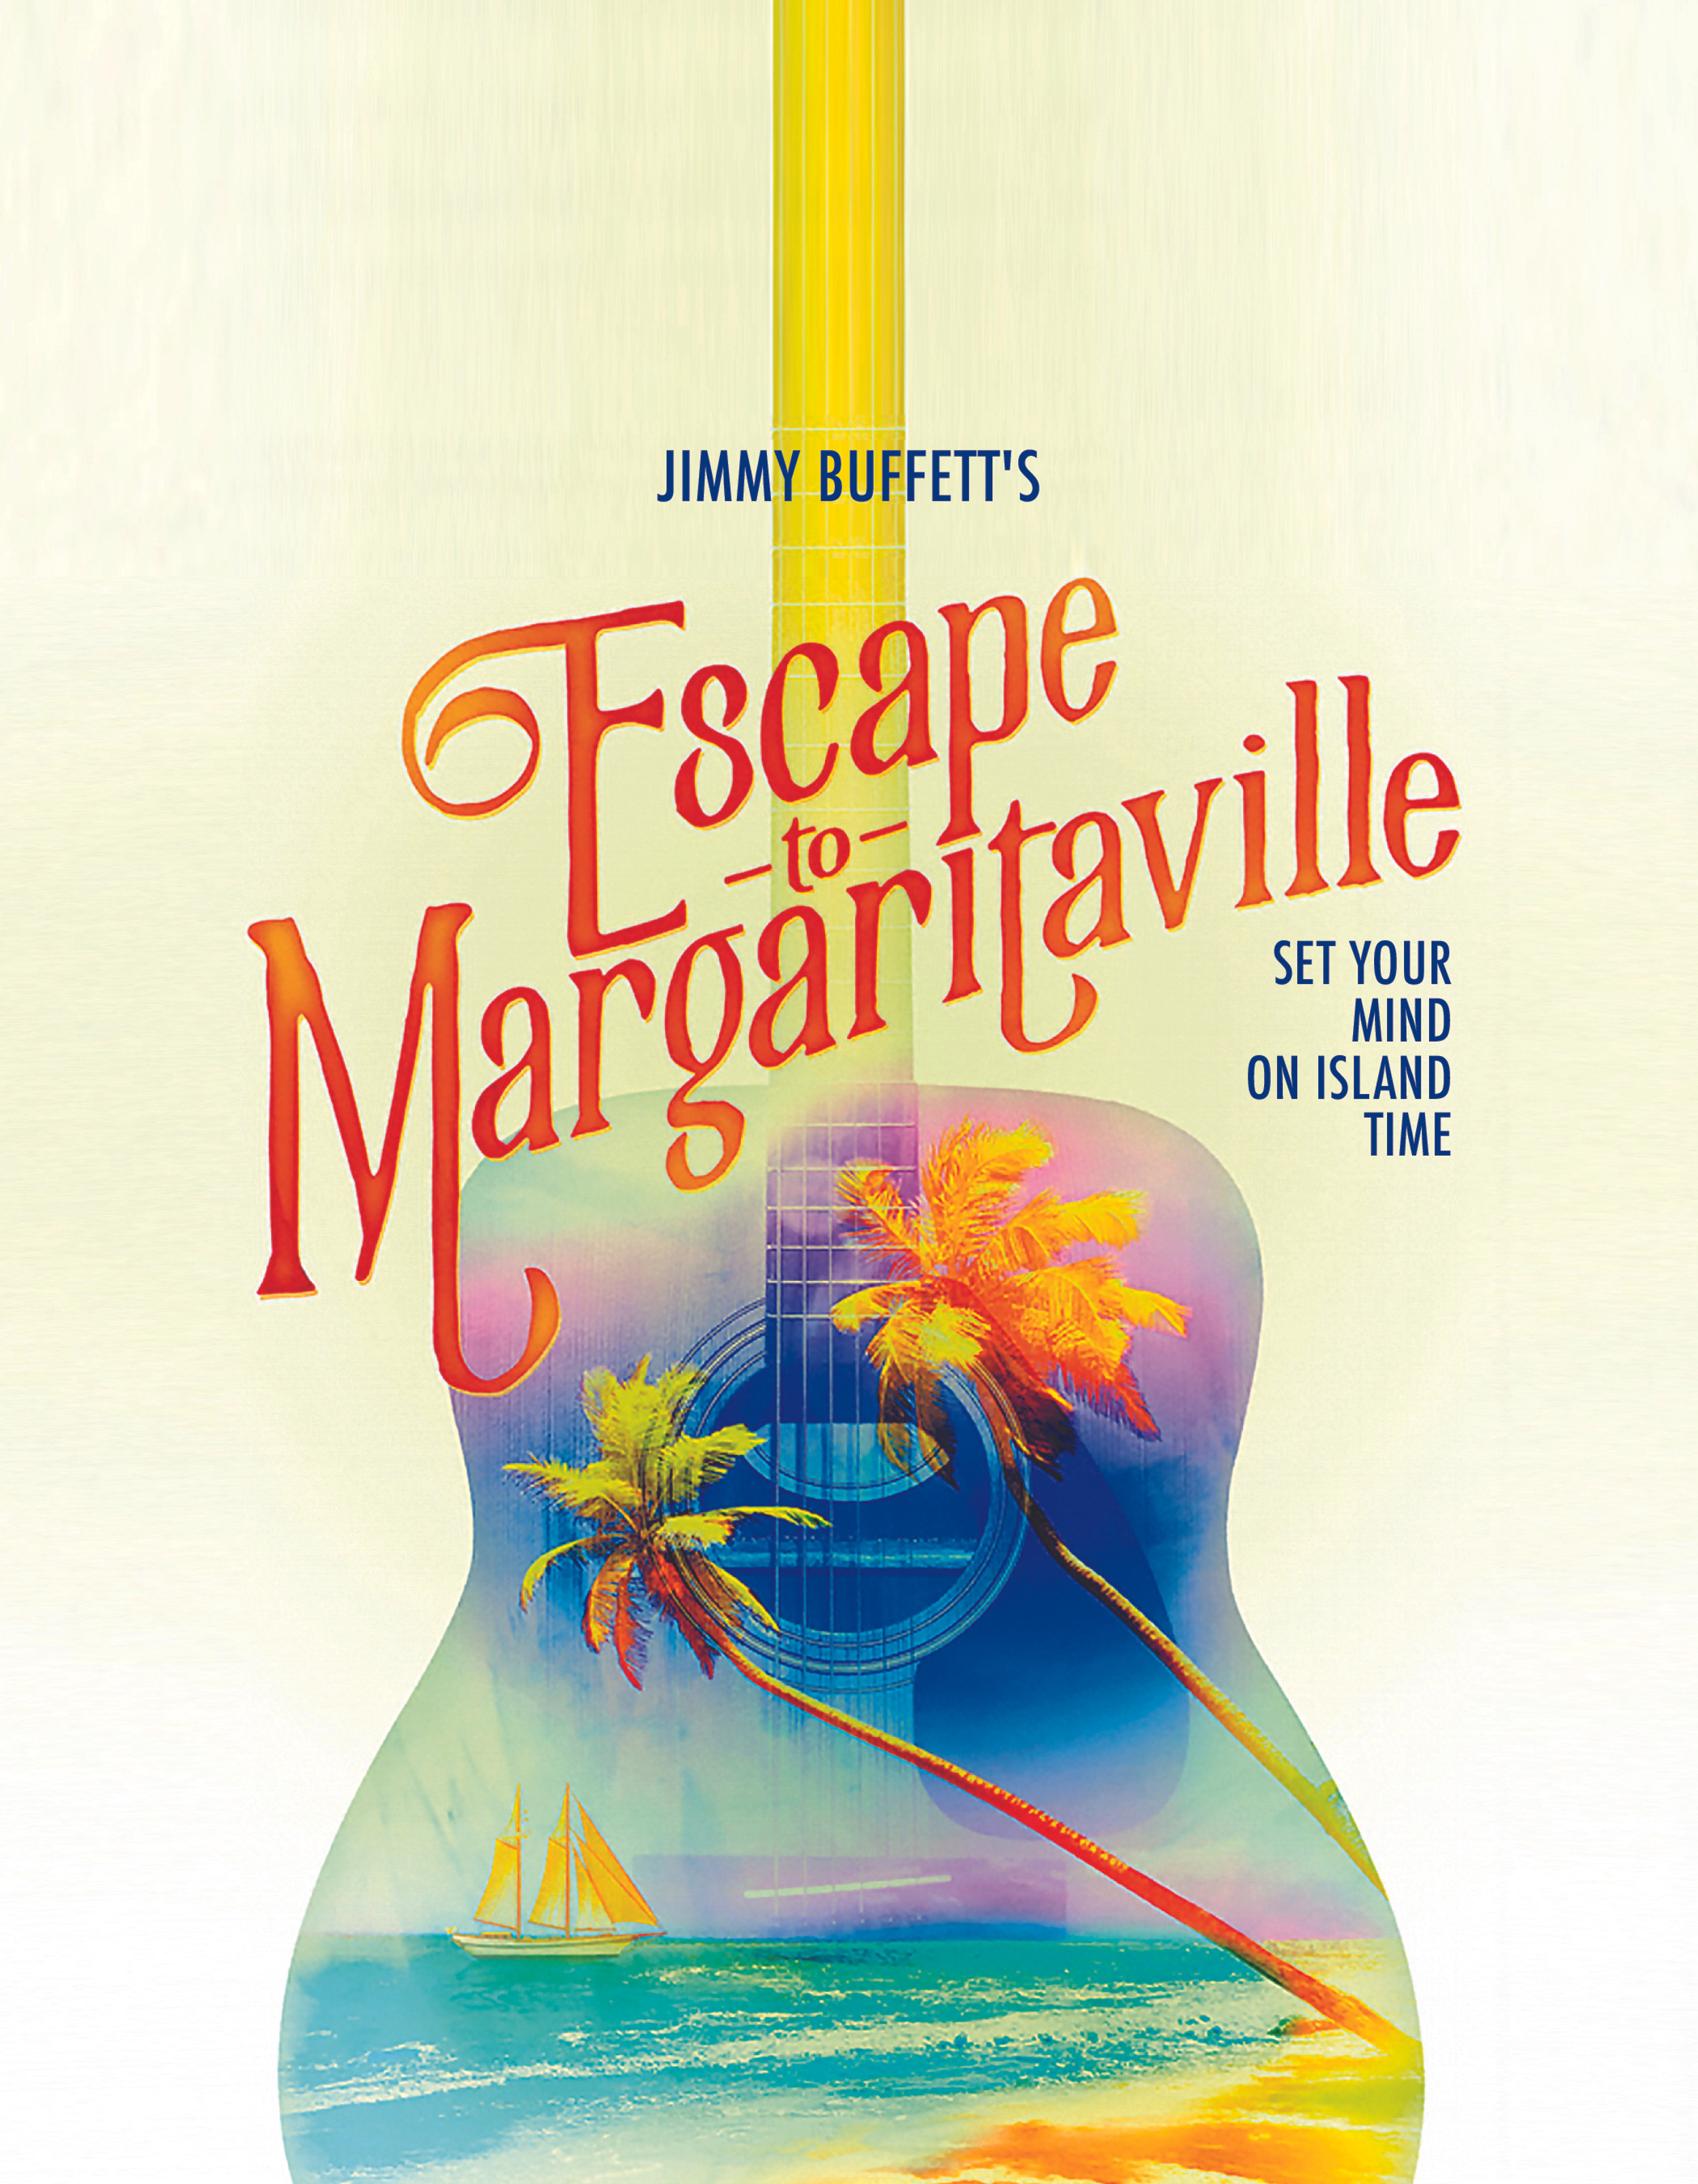
JIMMY BUFFET’S ESCAPE TO MARGARITAVILLE
Aug. 21 – Sept. 15, 2024
COMPOSER/LYRICIST, Jimmy Buffet; Book by GreG Garcia and Mike O’Malley
Jimmy Buffett’s Escape to Margaritaville is a musical comedy featuring the most-loved Jimmy Buffett classics, including “Cheeseburger in Paradise”, “Margaritaville,” “It’s Five O’Clock Somewhere,” “Fins,” “Volcano,” and many more. With a book by Emmy Award winner Greg Garcia (“My Name is Earl,” “Raising Hope”) and Emmy nominee Mike O’Malley (“Survivor’s Remorse,” “Shameless”), this hilarious, heartwarming musical is the summer party you’ve been waiting for!

How to Renew your tickets:
- Want to keep the seats you had in 2023? Renew by Friday, March 1, 2024
- Subscriptions can be purchased by mail with this form; by phone at 513.241.6550; fill out form on our website; or in person at either of our theaters.
- We will do our very best to accommodate your request.
- Each summer classic show at the Warsaw Federal Incline Theater runs for 4 weeks.
- Performances run Wednesdays and Thursdays @ 7:30pm, Fridays and Saturdays @ 8:00pm and Sundays @ 2pm.
- A subscriber can exchange for another date of the same show if you can’t make it on your performance day, based on availability.
- The front half of the theater is sloped with ramp for ease of access. The stage is elevated by 3 feet and Row A is 3 feet from the stage. There is ample room between each row so every seat has great leg room. The back of the theater has steps. Wheelchair seating is located in Row I.
- There is onsite parking available to you in a Public Garage for a $5.00 parking fee. The upper lot is adjacent to the lobby and the entrance is located at the back of the building from Mt. Hope.
Complete Performance Dates
Warsaw Federal Incline Theater 2024 Summer Classic Season

BEAUTIFUL: THE CAROLE KING MUSICAL
Wed., April 17, Thurs., April 18, Fri., April 19, Sat., April 20, Sun., April 21
Wed., April 24, Thurs., April 25, Fri., April 26, Sat., April 27, Sun., April 28
Wed., May 1, Thurs., May 2, Fri., May 3, Sat., May 4, Sun., May 5
Wed., May 8, Thurs., May 9, Fri., May 10, Sat., May 11, Sun., May 12

JERSEY BOYS
Wed., May 29, Thurs., May 30, Fri., May 31, Sat., June 1, Sun., June 2
Wed., June 5, Thurs., June 6, Fri., June 7, Sat., June 8, Sun., June 9
Wed., June 12, Thurs., June 13, Fri., June 14, Sat., June 15, Sun., June 16
Wed., June 19, Thurs., June 20, Fri., June 21, Sat., June 22, Sun., June 23

PETER AND THE STARCATCHER
Wed., July 10, Thurs., July 11, Fri., July 12, Sat., July 13, Sun., July 14
Wed., July 17, Thurs., July 18, Fri., July 19, Sat., July 20, Sun., July 21
Wed., July 24, Thurs., July 25, Fri., July 26, Sat., July 27, Sun., July 28
Wed., July 31, Thurs., Aug. 1, Fri. Aug. 2, Sat., Aug. 3, Sun., Aug. 4

JIMMY BUFFET’S ESCAPE TO MARGARITAVILLE
Wed., Aug. 21, Thurs., Aug. 22, Fri., Aug. 23, Sat., Aug. 24, Sun., Aug. 25
Wed., Aug. 28, Thurs., Aug. 29, Fri., Aug. 30, Sat., Aug. 31, Sun., Sept. 1
Wed., Sept. 4, Thurs., Sept. 5, Fri., Sept. 6, Sat., Sept. 7, Sun., Sept. 8
Wed., Sept. 11, Thurs., Sept. 12, Fri., Sept. 13, Sat., Sept. 14, Sun., Sept. 15

Subscriptions are on sale now! Current Subscribers can renew and request upgrades and we can seat any new Subscribers now.
- Want to keep the seats you had in 2023? Renew by Friday, March 1, 2024
- Season tickets will be mailed: Friday, March 15, 2024
- Single show tickets go on sale: Starting Monday, March 18, 2024
- Single show tickets prices: Adults $33.00; Students and Seniors $30.00

Purchase ’24 Summer Classic Subscription by one of the following methods:
- Call the box office @ 513.241.6550
- Mail your order form to: CLP P.O. Box 5255 Cincinnati, OH 45205
- Online at www.CLPShows.org
- In person at either of our theater box office ticket counters located at:

- The Warsaw Federal Incline Theater, 801 Matson Place, Cincinnati, OH 45204
- The Covedale Center for The Performing Arts, 4990 Glenway Ave. Cincinnati, OH 45238
- Box office hours at both theaters: Monday – Friday 11am to 5pm.

Warsaw Federal Incline Theater

For Office use only D_____ S_____ U_____

Warsaw Federal Incline Theater Summer
Order Form for 2024

Name: ______________________________ Email:_________________________________

Address/City/State/Zip: _________________________________________________________

Home Phone #: ______________________ Alternate #: _____________________________

SUBSCRIPTION ORDER PAYMENT INFORMATION:

I would like _____ Subscriptions to the Summer Classic Season at
The Warsaw Federal Incline Theater 2024 @ $112.00 each for a total of $______________

-----------------------------------------------------------------------------------------------------------------------------------------------------------
Warsaw Federal Incline Theater Summer Classic Series Day and Seating REQUEST:
(Choose a performance schedule below - one day and one week for series)
Were you a 2023 Summer Subscriber? YES _____ NO ______
Check here if you wish your day and seats to remain the same. ______
Renewing Subscribers are guaranteed their same seats, only if they keep the same day and week AND renew by the deadline of Friday, March 1, 2024.

Check here if you would like to change your series choice below. ______
Seating changes or upgrades are filled on availability and in the order received.
-----------------------------------------------------------------------------------------------------------------------------------------------------------------

DAY AND TIME WEEK of Performance
(Choose performance schedule below - one day & one week for Warsaw Federal Summer Classic series)
______Wednesday 7:30pm _____ Best Available
_____ Thursday 7:30 pm _____ 1st Week of Run
_____ Friday 8:00 pm _____ 2nd Week of Run
_____ Saturday 8:00 pm _____ 3rd Week of Run
_____ Sunday 2:00 pm _____ 4th Week of Run

PAYMENT OPTION INFORMATION:  Enclosed is my check made payable to Cincinnati Landmark Productions  ________ (Please “X” if check is enclosed) | Payment Address:  Cincinnati Landmark Productions  P.O. Box 5255  Cincinnati, OH 45205
Credit Card Payment: Name on Card: _________________________________________

Credit Card Number: ______________________________ Expiration Date:________________

