Covedale Center for the Performing Arts
2026 – 2027 Marquee Subscription Season
at the
Arnold and Mary Jo Barnett Performance Hall

ON SALE NOW!!!!

Enjoy great theatrical entertainment – at a great price! The subscriber rate is $32.00 per ticket ($128.00 for 4 show package). The Covedale has plenty of subscription seats available with excellent views of the stage! New subscribers are encouraged to get their seats now for best seating choices. Visit www.CLPShows.org for more information all year long.

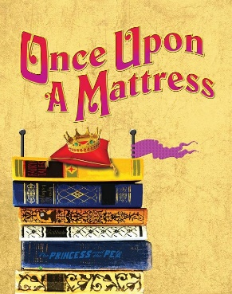
Once Upon A Mattress October 8 – November 1, 2026
Music by Mary Rodgers Lyrics by Marshall Barer
Book by Jay Thompson, Dean Fuller and Marshall Barer
Many moons about in a far-office place, Queen Aggravain decreed no couples could marry until her son Price Dauntless, found a bride Princesses came from far and wide to win the hand of the prince, but none could pass the impossible tests given to them by the Queen That is until the “shy” swamp princess, Winnifred the Woebegone, showed up. Would she be able to pass the Sensitivity test, marry her prince and help Lady Larken and Sir Harry to the altar? Carried on a wave of wonderful songs, by turns hilarious and raucous; romantic and melodic, this rollicking spin on the classic tale The Princess and the Pea, provides some side-splitting shenanigans. For after all, a princess is a delicate thing.
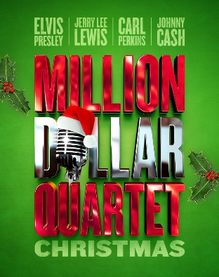

Millon Dollar Quartet Christmas

December 3 – December 27, 2026
Book by Colin Escott
The perfect sequel to the hugely successful MILLION DOLLAR QUARTET, Johnny Cash, Jerry Lee Lewis, Carl Perkins and Elvis Presley® come together again in MILLION DOLLAR QUARTET CHRISTMAS. Featuring an array of rockin’ Christmas classics, it’s a holiday celebration that will have you on your feet and dancing in the aisles. A continuation of their unforgettable jam session, the famous quartet festively decorates Sun Records. Sharing stories of their Christmas experiences past, present, and future, our four chart-topping artists perform one terrific musical number after another.

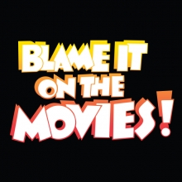
Blame It On The Movies
January 21 – February 14, 2027
Original Music and Lyrics by
Billy Barnes Musical Sequences Compiled and Conceived by
Billy Barnes Ron Abel and David Galligan
With a staggering collection of over 75 of the most well-known songs from the most well-known films, ranging from Gone with the Wind to Footloose, Blame It on the Movies! is a delicious romp through cinematic history. You’ll be guided through a cavalcade of the most memorable music from the movies. Blame It on the Movies! features unforgettable tunes from The Wizard of Oz, Meet Me in St. Louis, The Pink Panther, Rocky, Psycho, Jaws, Goldfinger, The Color Purple and countless others. It's a fun-filled homage to movie musicals, screwball comedies, shoot-em-up Westerns, sizzling screen romances, thrillers, action-adventure flicks, historical epics and auteurs alike.

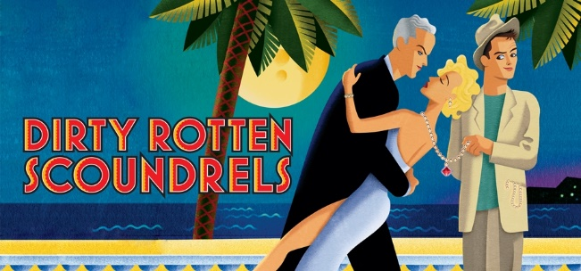
Dirty Rotten Scoundrels
March 11 – April 4, 2027
Book by Jeffrey Lane
Music and Lyrics by David Yazbek
Based on the film, Dirty Rotten Scoundrels, written by Dale Launer and Stanley Shapiro & Paul Henning
Dirty Rotten Scoundrels, based on the popular 1988 MGM film, takes us to the French Riviera for high jinks and hilarity.
Lawrence Jameson makes his lavish living by talking rich ladies out of their money. Freddy Benson more humbly swindles women by waking their compassion with fabricated stories about his grandmother's failing health. After meeting on a train, they attempt to work together, only to find that this small French town isn't big enough for the two of them. They agree on a settlement: the first one to extract $50,000 from a young female target, heiress, Christine Colgate, wins, and the other must leave town. A hilarious battle of cons ensues that will keep audiences laughing, humming and guessing to the end!

IMPORTANT DATES:
Subscriptions on sale Thursday, December 4, 2025
Subscription renewal deadline is Friday, August 21, 2026
Subscription package tickets will be mailed Friday, September 4, 2026
Single tickets go on sale, Tuesday, September 8, 2026
Single ticket pricing: $37.00 for Adults; $34 for Students and Seniors

Due to availability, season titles are subject to change.
Please note performance times: Thursday, Friday & Saturday 7:30 pm; & Sunday 2:00 pm.

Complete Performance Date Listing:

Once Upon A Mattress Blame It On The Movies
Thurs. Oct. 8 - Fri. Oct. 9 – Sat. Oct. 10 – Sun. Oct. 11 Thurs. Jan. 21 - Fri. Jan. 22 – Sat. Jan. 23 – Sun. Jan. 24
Thurs. Oct. 15 - Fri. Oct. 16 – Sat. Oct. 17 – Sun. Oct. 18 Thurs. Jan. 28 - Fri. Jan. 29 – Sat. Jan. 30 – Sun. Jan. 31
Thurs. Oct. 22 - Fri. Oct. 23 – Sat. Oct. 24 – Sun. Oct. 25 Thurs. Feb. 4 – Fri. Feb. 5 – Sat. Feb. 6 – Sun. Feb. 7
Thurs. Oct. 29 – Fri. Oct. 30 – Sat. Oct. 31 – Sun. Nov. 1 Thurs. Feb. 11 – Fri. Feb. 12 – Sat. Feb. 13– Sun. Feb. 14

Million Dollar Quartet Christmas Dirty Rotten Scoundrels
Thurs. Dec. 3 – Fri. Dec. 4 – Sat. Dec. 5 – Sun. Dec. 6 Thurs. Mar. 11 – Fri. Mar. 12 – Sat. Mar. 13 – Sun. Mar. 14
Thurs. Dec. 10 – Fri. Dec. 11 – Sat. Dec. 12 – Sun. Dec. 13 Thurs. Mar. 18 – Fri. Mar. 19 – Sat. Mar. 20 – Sun. Mar. 21
Thurs. Dec. 17 – Fri. Dec. 18 – Sat. Dec. 19 – Sun Dec. 20 Thurs. Mar. 25 – Fri. Mar. 26 – Sat. Mar. 27 – * Sun. Mar. 28
Tues. Dec. 22 – Wed. Dec. 23 - Sat. Dec. 26 – Sun. Dec. 27 Thurs. Apr. 1 – Fri. Apr. 2 – Sat. Apr. 3 – Sun. Apr. 4
*Sunday March 28, 2027, is Easter
For Million Dollar Quartet Christmas We will be performing on Easter Sunday
Thurs. #4 subscribers are moved to
Tues. Dec. 22nd at 7:30pm due to the Christmas Holiday
And
Fri. #4 subscribers are moved to
Wed. Dec. 23rd at 7:30 pm due to the Christmas Holiday

You can purchase OR renew a subscription by one of the following methods:
- Call the box office @ 513.241.6550
- Mail your subscription order form to: CLP, P.O. Box 5255 Cincinnati, OH 45205
- Log on to: www.CLPShows.org
- In person at the Covedale or Incline box office ticket counters
- Single tickets go on sale Tuesday, September 8, 2026 $37 for Adults; $34 for Seniors/Students

Covedale Center for the Performing Arts
Seating Chart

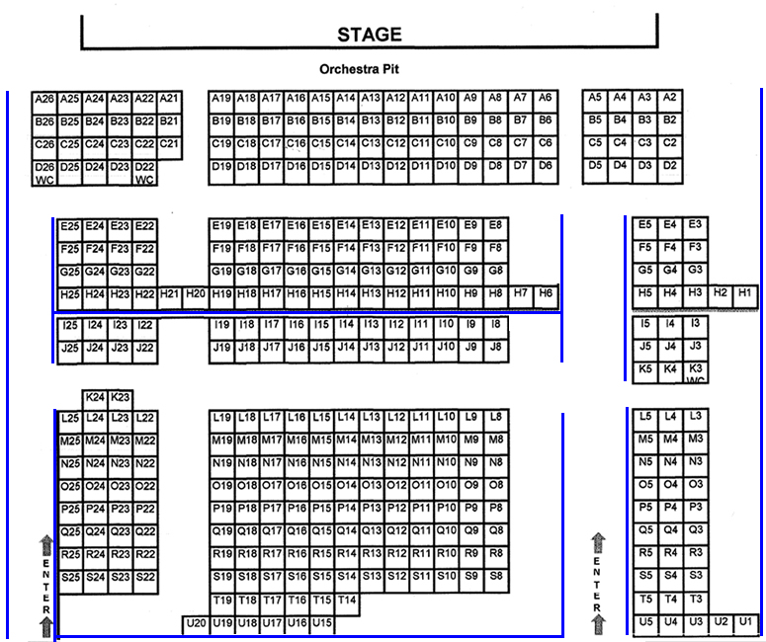

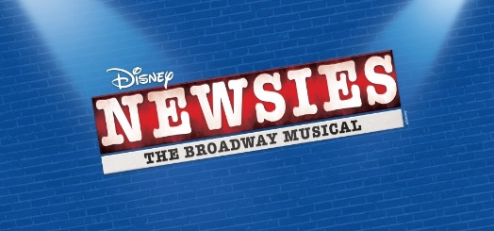
Don’t Miss Cincinnati Young People’s Theatre’s 44th Summer!

Newsies July 23 – August 2, 2026
Music By Alan Menken, Lyrics By Jack Feldman
Booked By Harvey Fierstein Based on the Disney film written by Bob Tzudiker and Noni White.
It's time to carry the banner on your stage with Disney's Newsies! Set in turn-of-the century New York City, Newsies is the rousing tale of Jack Kelly, a charismatic newsboy and leader of a band of teenaged "newsies." When titans of publishing raise distribution prices at the newsboys’ expense, Jack rallies newsies from across the city to strike against the unfair conditions and fight for what's right! Based on the 1992 motion picture and inspired by a true story, Newsies features a Tony Award-winning score by Alan Menken (Little Shop of Horrors, Sister Act) and Jack Feldman and a book by Tony Award winner Harvey Fierstein (Kinky Boots). Featuring the now classic songs “Carrying the Banner,” “Seize the Day,” and “Santa Fe,” Newsies is packed with non-stop thrills and a timeless message, perfect for the whole family!

For information on all the shows at all of our great venues, check out: www.clpshows.org

For Office use only D_____ S_____ U_____

Covedale Center for the Performing Arts
Subscription Order Form for 2026– 2027 Season
(Please fill out completely)

Name: ________________________________ Email:___________________________________

Address/City/State/Zip: ____________________________________________________________

Home Phone #: __________________________ Alternate #: ____________________________

SUBSCRIPTION ORDER INFORMATION:
I would like _____ Marquee series Subscriptions @ $128.00 each for a total of……….. $________
A subscription INCLUDES All Four Season Shows.
The Subscription Package features the low, Subscriber - only price of $32.00 per show.

DONOR SUPPORT ------------ Diamond Level $1,000.00 and above ________
Platinum Level $ 500.00 and above ________
Won’t you consider a tax-deductible donation Gold Level $ 250.00 and above ________
To help keep CLP growing? If you have Silver Level $ 100.00 and above ________
not contributed to our Annual Giving
Campaign, you can make a donation now.

TOTAL AMOUNT (Subscriptions + Donor Support) = $ _______________

PAYMENT OPTION INFORMATION:  Enclosed is my check made payable to  Cincinnati Landmark Productions: ________  (Please “X” if check is enclosed) | Payment Address:  Covedale Center for the Performing Arts  P.O. Box 5255  Cincinnati, OH 45205
Credit Card Payment: Name on Card: ____________________________________
Credit Card Number: ____________________________________
Expiration Date: ____________________________________
Billing Zip Code: _________________ CVV:______________

SERIES PERFORMANCE REQUEST: (Choose a performance schedule below - one day and one week for series)
Were you a 2025-26 Marquee Season Subscriber? YES _____ NO ______

__________ Check here if you wish your day and seats to remain the same.
- Renewing Subscribers are guaranteed their same seats, only if they keep the same day and week AND renew by the deadline.
_______________ Check here if you would like to change your series choice below.
- Seating changes or upgrades are filled on availability and in the order received.

DAY AND TIME WEEK
_____ Thursday 7:30 pm _____ No Preference
_____ Friday 7:30 pm _____ 1st Week of Run
_____ Saturday 7:30 pm _____ 2nd Week of Run
_____ Sunday 2:00 pm _____ 3rd Weed of Run
_____ 4th Week of Run
Please specify wheelchair needs:____________________________________________________

You can purchase OR renew a subscription by one of the following methods:
- Call the box office @ 513.241.6550
- Mail your subscription order form to: CLP P.O. Box 5255 Cincinnati, OH 45205
- Log on @ www.clpshows.org
- In person at the Covedale or Incline box office ticket counters

